Lab report 08


CSE 402L
Digital Signal Processing Fall 2024

Submitted by: Naveed Ahmad
Registration No.: 22PWCSE2165
Class Section: B
Semester :5th

Student Signature: ____________

Submitted to:
Dr. Yasir Saleem Afridi

Dec. 24, 2024

Department of Computer Systems Engineering
University of Engineering and Technology Peshawar

SIMULINK TRAINING TO DEMONSTRATE THE USE OF SIMULINK PRODUCTS
Task:
Visit the following website: https://www.mathworks.com/learn/tutorials/simulink-onramp.html and perform the following tasks and attach the Certificate/ Progress Report acquired from MathWorks as part of the lab Report
OBJECTIVES:
- Course Overview
    - to learn about the Simulink Onramp course.
    - to understand the basics of Simulink software.
    - and get ready to start hands-on practice.

- Simulink Graphic Environment

      - Simulink Blocks: Blocks represent different parts of a system (e.g., mathematical operations, integrators, sources of signals). For example:
      - Source blocks: Generate input signals (e.g., step, sine wave).
      - Math blocks: Perform operations like addition, multiplication, etc.
      - Scope blocks: Display results of simulations.
      - Signals: Signals carry information between blocks. They can represent data like time, position, velocity, or force, and are connected between blocks using lines in the Simulink environment.

- Inspecting Signals
- Signals carry information between blocks in your model.
- Visualizing signals means seeing how the values change over time.
- Use the Scope block to show graphs of these values during the simulation.

Screenshot
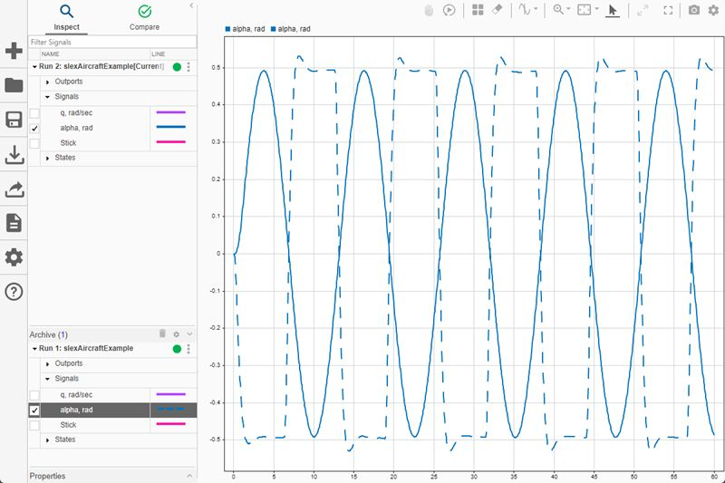
Develop simple algorithms and solve basic problems in Simulink by mastering the use of math and logic blocks.

Screenshot:

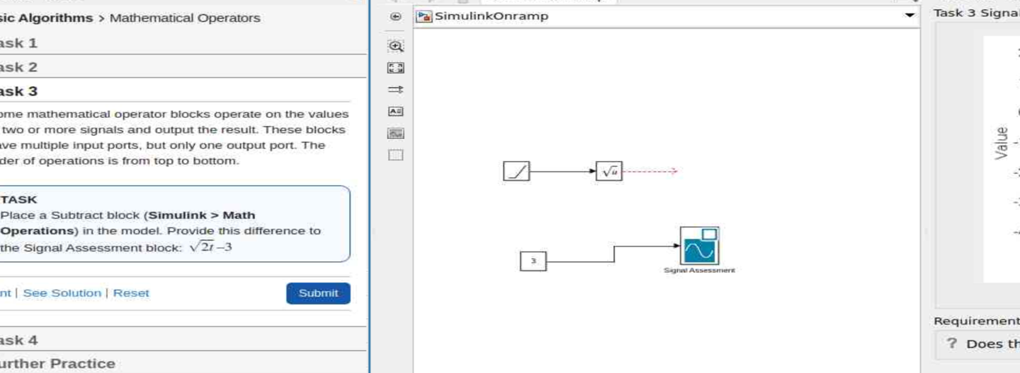
Learnt to open Simulink help. Use documentation and understood blocks. Found answers to our questions easily.

Screenshot:
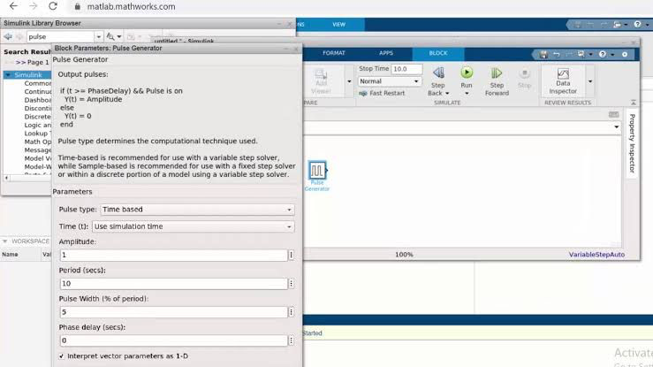
Simulink and MATLAB offer math and logic operators for calculations and decision-making. Simulink models dynamic systems with changing states over time. It also supports discrete-time systems, enabling step-by-step simulations.

Screenshot:
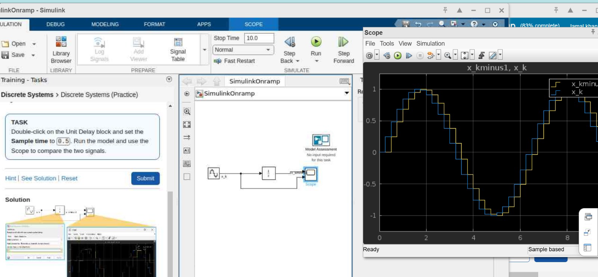

1. Continuous-time systems - These systems change continuously, like car motion or electricity flow.
2. Modeling - Simulink uses blocks (e.g., integrators, transfer functions) to model and simulate system behavior.
3. Block Connections - Connecting blocks creates continuous models to simulate system behavior over time.
4. Simulation Time - Set how long the simulation runs (e.g., 10 seconds, 1 minute).
5. Control Settings - Simulation duration defines how long the system’s behavior is modeled.

Screenshot:
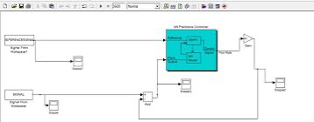

Project - Modeling a Thermostat
Simulate a discrete system where the thermostat checks temperature at intervals and switches on/off based on conditions.
Project - Peregrine Falcon Dive
Model forces acting on a falcon during a dive using blocks for gravity, drag, and net force. Simulate velocity and position changes over time.

Conclusion:
The Simulink Onramp course teaches modeling and simulating dynamic systems using blocks and signals. It helps visualize real-world behavior and develop essential simulation skills.

Progress report:
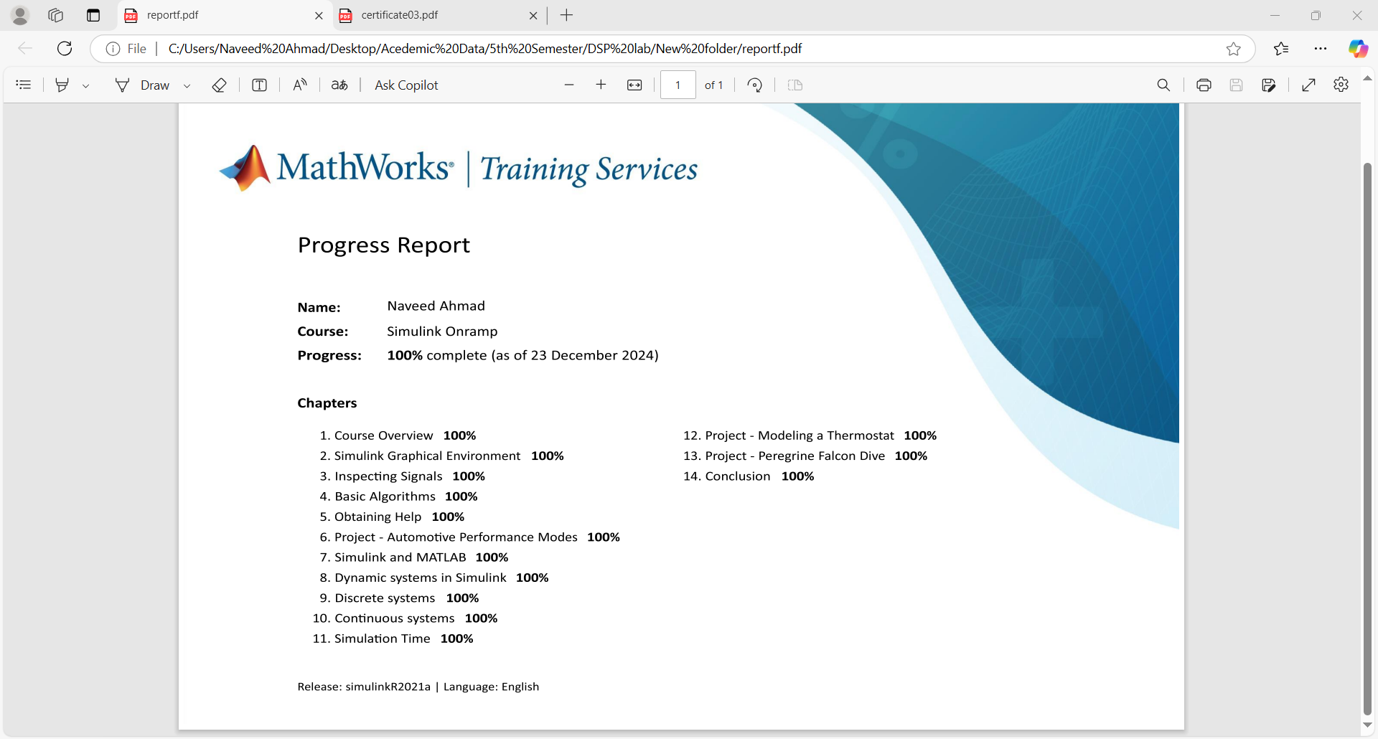

Certificate:
